Atharv Arya

1BM18CS020

PROGRAM TITLE: LDR-NIGHT LIGHT SIMULATION

## Aim: DEMONSTRATE AND SHOW ON/OFF OF A LED USING LDR-NIGHT LIGHT SIMULATION

Hardware Required:

* Arduino Board
* LED
* Photoresistor
* Resistor
* Breadboard Circuit Diagram:

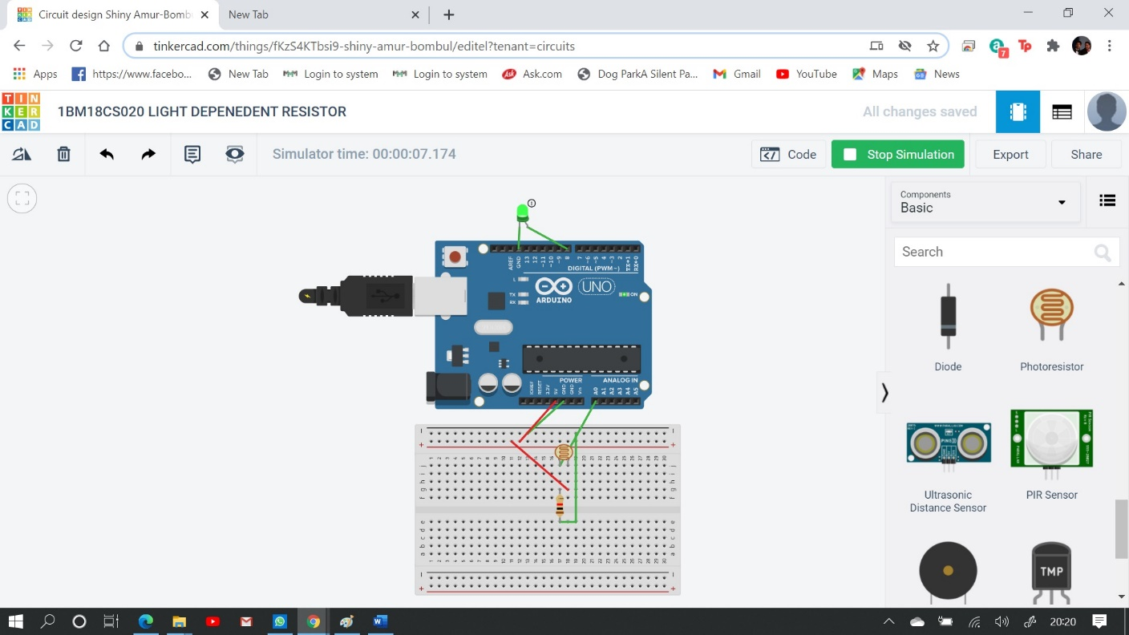

Write-Up:

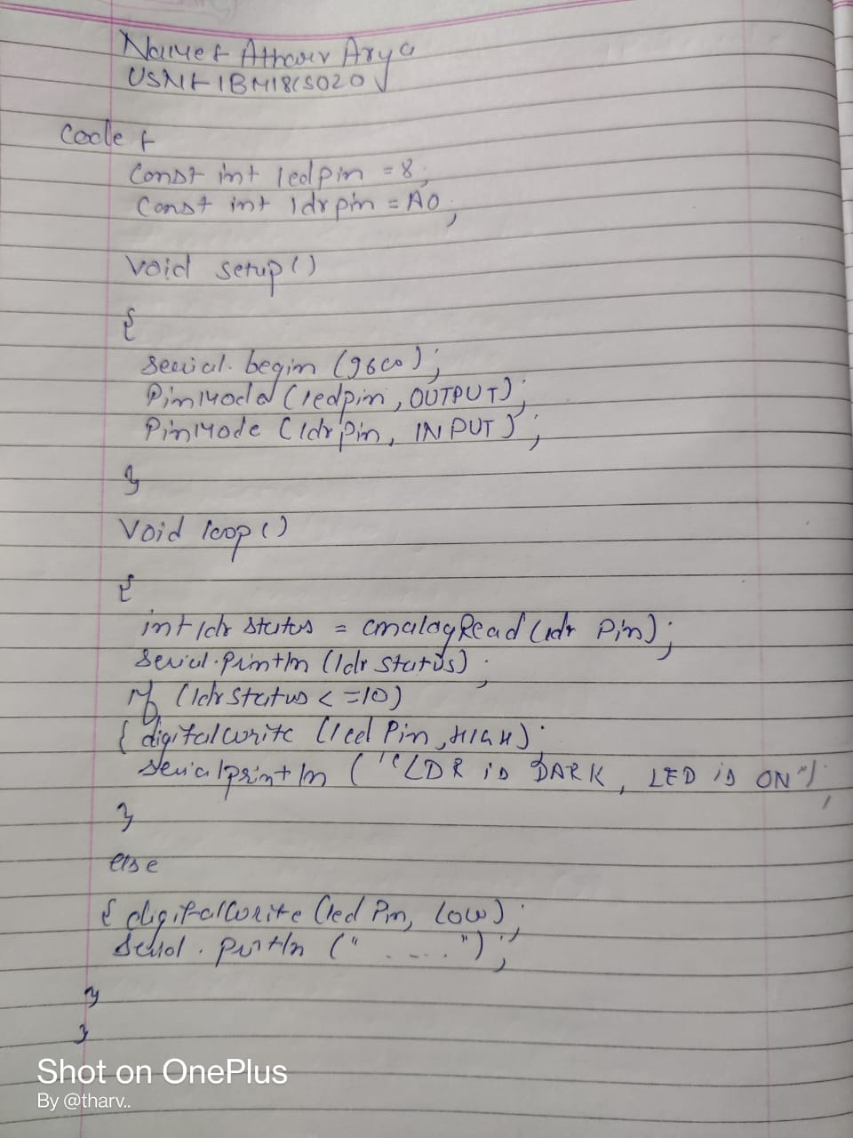

CODE:

const int ledPin = 8; const int ldrPin=A0;

void setup()

{

Serial.begin(9600); pinMode(ledPin,OUTPUT); pinMode(ldrPin,INPUT);

}

void loop()

{

int ldrStatus = analogRead(ldrPin); Serial.println(ldrStatus); if(ldrStatus<=10)

{ digitalWrite(ledPin,HIGH); Serial.println("LDR is DARK,LED is ON");

}

else

{ digitalWrite(ledPin, LOW); Serial.println(" ");

}

}

## OUTPUT/OBSERVATION: LED is ON.